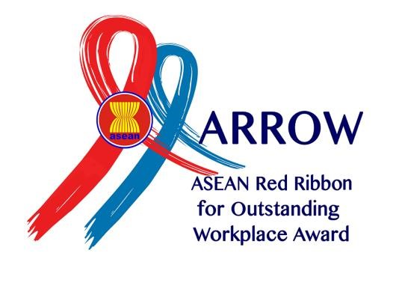
NOMINATION FORM

The 5th ASEAN Red Ribbon for Outstanding Workplace (ARROW) Award 2024

Thailand

Company Profile

Name of Company
Sector of Business
Number of Workers | - Male
 | - Female
 | Total
Address
Contact Person | - Name
 | - Designation in the Company
 | - Phone Number
 | - Email

- Detail Information on Implemented HIV-AIDS Programs:

HIV-AIDS Awareness Programs for Workers

Type of  Activities/Program | Number of  Participant (Program Coverage) | Remarks
(Examples: Talk Shows HIV-AIDS Issues on World Aids Days) | (Examples :100 Participant) | Document support for activities are:  -Photos (attached)  -Media coverage (attached)

Training/Capacity Building

Type of  Activities/Program | Number of  Participant (Program Coverage) | Remarks
(Examples: Training of Trainer  HIV-AIDS at Workplace) | (Examples :20 Participant) | Document support for activities are:  - Photos (attached)  - Certificates (attached)  - Media Coverage (attached)

Voluntary Counselling and Testing (VCT) and HIV Care, Support and Treatment (CST) Program
Type of  Activities/Program | Number of  Participant (Program Coverage) | Remarks
(Examples: provide counsellor &  VCT Clinic, referral system to VCT  & CST service centre, mobile VCT) | (Examples :20 Participant) | Document support for activities are:  -Photos (attached)  -Attendant list (attached)  -Certificates (attached)

Provide Information Education and Communication (IEC) Materials

Type of  Activities/Program | Number of  Participant (Program Coverage) | Remarks
(Examples: created Leaflet,  Sticker, Poster) | (Examples: Distributed 100 copy IEC with coverage area 2 branch company) | Document support for activities are:  -Photos of Leaflet, Poster, Sticker.

Corporate Social Responsibility (CSR) Program on HIV-AIDS

Type of  Activities/Program | Number of  Participant (Program Coverage) | Remarks
(Examples: Socialization HIV-  AIDS at School by workers) | (Examples :20 Participant) | Document support for activities are:  -Photos (attached)  -Media coverage (attached)

Programme Management: Administration, Reporting systems, and Evaluation

Type of  Activities/Program | Number of  Participant (Program Coverage) | Remarks
(Examples: Created Knowledge,  Attitude, and Practice HIV-AIDS  Surveys regularly) | (Examples :100 Participant) | Document support for activities are:  -Document Survey (attached)  -Results of Surveys (attached)  - Photos (attached)

C. Please attached the documents as follows:

- The Company policy and program on HIV-AIDS.
- Organizational structure of implementers on OSH and HIV-AIDS program. (Ex. Committees, groups, or unit assigned to implement the HIV and AIDS policy and program)
- Photos of program/activities, activities’ attendant list, certificates received, IEC materials, video etc., related to the HIV-AIDS program.
- Website link to the program.

Note:
Submit all the documents for nomination of ARROW Award to ASEAN BCA Secretariat on or before June 30, 2024 to:

Contact Persons:

ASEAN-BCA Secretariat 2023-2024
Email: thbcacoordinator@gmail.com

and copy to :

Mr. Thanin Pumaroon
Director of Labour Welfare Division
Department of Labour Protection and Welfare
Email: Pumaroon@yahoo.com

Ms. Supee Srithongtab
Labour officer - Professional level
Email: supee.s@labour.mail.go.th

Mr. Phornchai Chiravinijnandh
Managing Director
Thailand Business Coalition on AIDS (TBCA)
Email: phornchai@tbca.or.th

- Each ASEAN Member State can only nominate 1 (one) national company according to existing relevant national awards mechanism.

Please fill in as applicable
Please provide as applicable

